COMMON COURSE ASSIGNMENT

S. Siva Archana(192511128)

Assignment Information

Particular | Details
Department: | CSE-AI
Course Code & Course Name | DSA0101 and Object Oriented Programming with C++
Academic Year / Batch | 3rd
Faculty Name | Dr.M.Gunasekaran
Assignment Title | Smart Civic Complaint and Public Safety Response System using C++
Date of Issue | 02-09-2026
Date of Submission | 03-09-2026
Maximum Marks | 100
Course Outcome(s) – CO | CO2: Design C++ programs by applying functions and object-oriented concepts such as classes, objects, access specifiers, member functions, static members, and arrays of objects to solve real-world programming problems.  CO3: Construct C++ programs using constructors, destructors, and operator overloading mechanisms to control object creation, destruction, and operator behaviour.  CO4: Analyse and implement C++ applications using inheritance, types of inheritance, virtual base classes, abstract classes, pointers, and polymorphism to design reusable and extensible programs.
Bloom's Taxonomy Level | L3 – Apply; L4 – Analyse
SDG Mapping (SDG 1-17) | SDG 9 – Industry, Innovation and Infrastructure; SDG 11 – Sustainable Cities and Communities; SDG 16 – Peace, Justice and Strong Institutions

Assignment Problem / Challenge
Faculty shall provide a realistic engineering/scientific/computing problem, case, challenge or design requirement related to the Course Outcome.
The assignment should preferably require students to:

  - Apply course concepts rather than reproduce theory.
  - Identify and analyze the problem.
  - Consider requirements and constraints.
  - Develop or compare alternative solutions where appropriate.
  - Use relevant modern engineering/computing/design tool
● Make and justify engineering decisions.
● Consider appropriate technical, economic, environmental, societal, ethical, safety or
sustainability factors wherever relevant.

Problem Statement

Problem / Case / Design Challenge:

[Faculty to provide the detailed assignment problem here.]

Requirements and Constraints
Students shall identify or be provided with relevant requirements and constraints. Examples include:
  - Functional requirements
  - Performance requirements
  - Technical constraints
  - Cost, Time
  - Resources
  - Safety
  - Reliability
  - Sustainability
  - Environmental and Ethical considerations
  - Standards/codes
  - User requirements
  - Manufacturability
  - Power/energy
  - Security/privacy

Only constraints relevant to the particular course/problem need to be considered.

Student Work

Problem Understanding and Formulation
The main problem is the inefficient handling of civic complaints and public-safety issues. A complaint management system should not only store complaints but also identify urgent cases and ensure that they receive faster attention.
The proposed system divides complaints into categories such as:
- Road and Infrastructure
- Garbage and Sanitation
- Streetlight
- Water Supply
- Traffic
- Public Safety
- Other Civic Issues
Priority can be assigned as:
Priority | Description
Critical | Immediate public-safety risk
High | Requires quick response
Medium | Normal civic issue
Low | Non-urgent complaint
The expected outcome is a structured system that helps administrators identify urgent complaints and manage the overall complaint lifecycle.

Application of Course Knowledge
The system applies the following C++ concepts:
C++ Concept | Application in Project
Classes and Objects | Represent citizens, complaints and response personnel
Structures | Store complaint information
Functions | Perform individual system operations
Vectors | Store multiple complaint records
Priority Queue | Manage urgent complaints
Searching | Find complaints using ID/category
Sorting | Arrange complaints by priority/date
File Handling | Save and retrieve complaint records

Solution / Design / Methodology

System Work Flow

START

↓

Citizen

↓

Register Complaint

↓

Enter Complaint Details

↓

Categorize Complaint

↓

Assign Priority

(Low / Medium / High)

↓

Store Complaint

↓

Priority Queue

↓

Assign Response / Department

↓

Update Status

(Pending / In Progress)

↓

Resolve Complaint

↓

Generate Report

↓

END

Complaint Processing
When a complaint is registered, the system generates a unique complaint ID. The complaint is then categorized and assigned a priority level.
Critical and high-priority complaints are placed ahead of normal complaints using a priority queue. This ensures that public-safety issues can be processed before less urgent civic problems.
The complaint status is updated throughout its lifecycle:
Pending → In Progress → Resolved

Use of Modern Tools
The implementation uses:
- C++ – Core programming language.
- Visual Studio Code / Code::Blocks – Development environment.
- G++ / MinGW – C++ compiler.
- STL – Vector, priority queue, sorting and searching.
- File handling – Persistent complaint storage.
- Git/GitHub – Version control, if applicable.

Results and Validation
The system can be validated using test cases such as:
Test Case | Input | Expected Output
1 | Add road complaint | Complaint successfully registered
2 | Add public-safety complaint | High/Critical priority assigned
3 | Search valid complaint ID | Correct complaint displayed
4 | Search invalid ID | Complaint not found
5 | Sort complaints | Complaints arranged by priority
6 | Update complaint | Status changed successfully
7 | Resolve complaint | Complaint marked as Resolved
8 | Display pending complaints | Only pending complaints displayed
9 | Multiple urgent complaints | Highest-priority complaint processed first
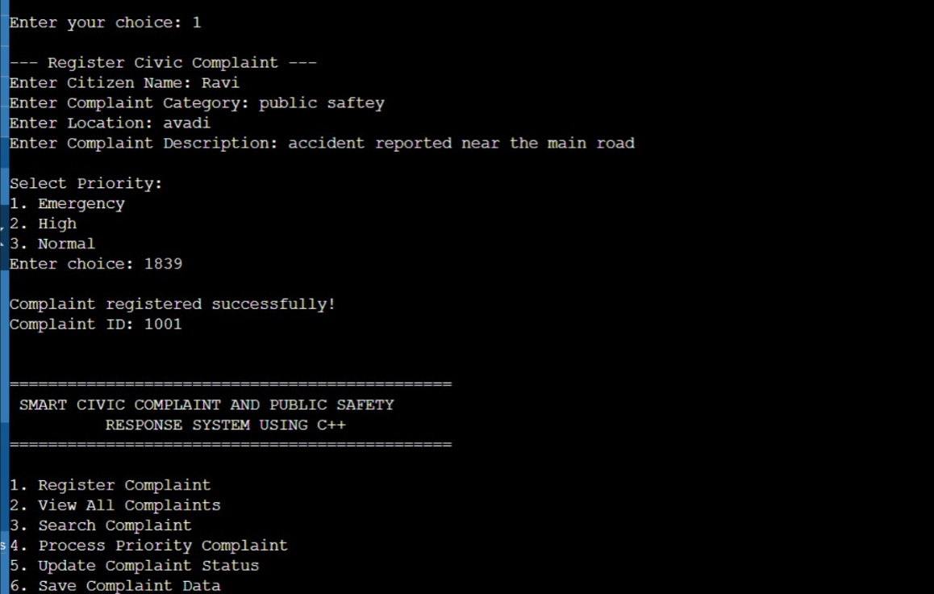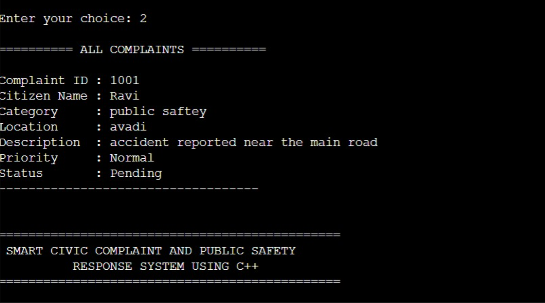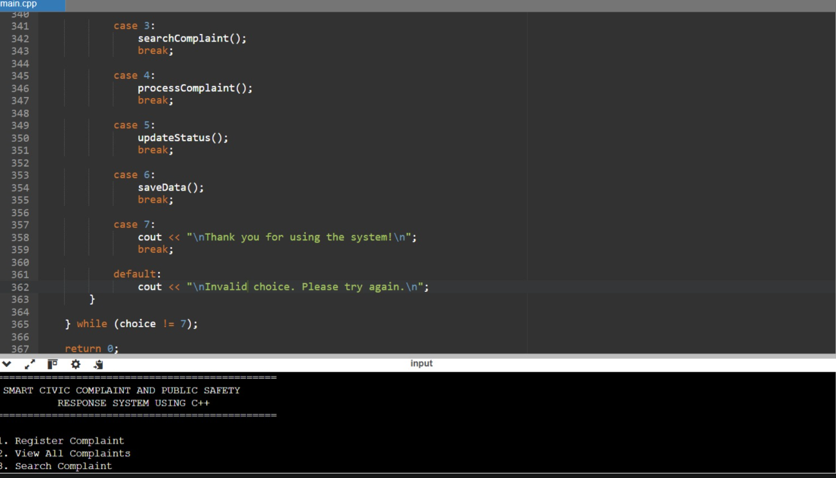

Expected Result

The system should correctly register complaints, prioritize urgent cases, retrieve records, update statuses, and maintain complaint information without data loss. It should ensure that every complaint is stored accurately with complete details and a unique identification number. The priority mechanism should help in handling urgent complaints quickly and efficiently. The system should allow authorized users to easily retrieve and update complaint records whenever required. Overall, the system should provide reliable data management, reduce processing errors, and ensure that complaints are properly tracked until they are resolved.

Analysis and Engineering Decision

A simple first-come-first-served queue can process complaints in the order they arrive, but it may cause critical safety complaints to wait behind less important issues.

Therefore, a priority queue is selected for complaint processing.
Approach | Advantage | Limitation
Normal Queue | Simple and fair order | Urgent complaints may be delayed
Priority Queue | Critical complaints receive faster attention | Requires priority management
Linear Search | Easy to implement | Slower for large datasets
Sorting + Search | Better organization | Additional processing required

The priority queue is selected because public-safety complaints require faster response than routine complaints.

Broader Considerations

Social Impact
The system can improve the organization of civic complaints and help authorities identify important public issues.

Safety
Critical complaints can be given higher priority, helping reduce delays in responding to potential public-safety risks.

Accessibility
A future graphical or web-based interface can make the system easier for citizens to use.

Privacy
Personal information associated with complaints should be protected and accessible only to authorized users.

Sustainability
A digital complaint system can reduce dependence on paper-based complaint records.

Conclusion
The Smart Civic Complaint and Public Safety Response System using C++ provides an organized approach for managing civic complaints. The system applies C++ programming concepts such as object-oriented programming, vectors, priority queues, searching, sorting, and file handling.
The priority-based processing mechanism helps identify urgent public-safety complaints and ensures that they receive appropriate attention. The proposed system demonstrates how fundamental programming and data-structure concepts can be applied to a practical societal problem.
The system applies C++ programming concepts such as object-oriented programming, vectors, priority queues, searching, sorting, and file handling.
The priority-based processing mechanism helps identify urgent public-safety complaints and ensures that they receive appropriate attention. The proposed system demonstrates how fundamental programming and data-structure concepts can be applied to a practical societal problem.

Student Reflection
Through this assignment, I learned how C++ programming concepts can be combined to solve a practical problem. I gained experience in designing classes, managing collections of records, using priority queues, implementing searching and sorting, and storing data using file handling.
If additional time and resources were available, I would improve the system by developing a GUI/web interface, database connectivity, real-time complaint tracking, location-based complaint mapping, notification services, and administrator authentication.

References

- Bjarne Stroustrup, The C++ Programming Language, Addison-Wesley.
- Stanley B. Lippman, Josée Lajoie and Barbara E. Moo, C++ Primer, Addison-Wesley.
- ISO/IEC 14882, Programming Languages – C++.
- C++ Standard Template Library documentation.
- OpenStreetMap documentation, for possible future location-based complaint mapping.
- Microsoft Visual Studio Code documentation, for development environment reference.

Common Assessment Rubric

Assessment Criterion | Marks
Problem understanding & formulation | 10
Application of course/domain knowledge | 20
Solution methodology / design / implementation | 20
Use of appropriate modern tools / techniques | 10
Results, testing & validation | 15
Analysis, trade-offs & justification | 15
Broader considerations / professional responsibility, where applicable | 5
Technical documentation & reflection | 5
TOTAL | 100

CO–PO–Assessment Mapping

Assessment Component | CO | PO(s) | Bloom's Level | Marks
Problem formulation |  |  | L3/L4 | 10
Application of knowledge |  |  | L3/L4 | 20
Solution / Design / Implementation |  |  | L4/L5/L6 | 20
Modern tool usage |  |  | L3/L4 | 10
Validation |  |  | L4/L5 | 15
Analysis & justification |  |  | L4/L5 | 15
Broader considerations |  |  | L4/L5 | 5
Documentation & reflection |  |  | L3/L4 | 5
Note: Faculty shall map only the POs and Bloom's levels genuinely assessed by the particular assignment. Every assignment is not required to map to every PO.

Faculty Evaluation & Continuous Improvement CO Attainment

Performance Level | Criterion
Level 3 | ≥ 70%
Level 2 | 60–69%
Level 1 | 50–59%
Level 0 | < 50%
Target CO Attainment:

Actual CO Attainment:

Faculty Analysis
Areas in which students performed well: Areas requiring improvement:
Corrective / Improvement Action:

Action to be implemented in the next offering:

Documents to be Maintained

The department/course faculty shall maintain:

- Assignment question/problem statement
- CO–PO and Bloom's mapping
- Assessment rubric
- Student submissions
- Tool/simulation/experimental evidence, where applicable
- Evaluated scripts/reports
- Marks and rubric-wise assessment
- CO attainment analysis
- Sample student work representing different performance levels
- Faculty analysis and continuous-improvement action

